  - Software architecture is the fundamental organization of a system, embodied in its components, their relationships to each other and the environment, and the principles governing its design and evolution

- Software architecture encompasses the set of significant decisions about the organization of a software system
  - Selection of the structural elements and their interfaces by which a system is composed
  - Behavior as specified in collaborations among those elements
  - Composition of these structural and behavioral elements into larger subsystems
  - Architectural style that guides this organization

- Architecture represents the set of earliest design decisions
  - Hardest to change
  - Most critical to get right
- Architecture is the first design artifact where a system’s quality attributes are addressed

- Architecture serves as the blueprint for the system but also the project:
  - Team structure
  - Documentation organization
  - Work breakdown structure
  - Scheduling, planning, budgeting
  - Unit testing, integration
- Architecture establishes the communication and coordination mechanisms among components

Architecture vs. Design
Architecture: where non-functional decisions are cast, and functional requirements are partitioned
Design: where functional requirements are accomplished

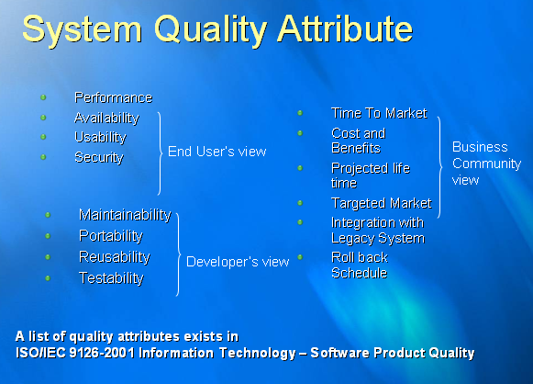

Business Architecture
- Concerned with the business model as it relates to an automated solution.

Technical Architecture
- Specific to technology and the use of this technology to structure the technical points (Technology Mapping) of an architecture
  - .NET
  - J2EE
  - Hardware architects

Solutions Architecture
- Specific to a particular business area (or project) but still reliant on being a technical focal point for communications between the domain architect, business interests and development.

Enterprise Architecture
- The organizing logic for a firm’s core business processes and IT capabilities captured in a set of principles, policies and technical choices to achieve the business standardization and integration requirements of the firm’s operating model.
- Concerned with cross project/solution architecture and communication between different practices in architecture.

Product Line Architecture
Common Architecture for a set of products or systems developed by an organization

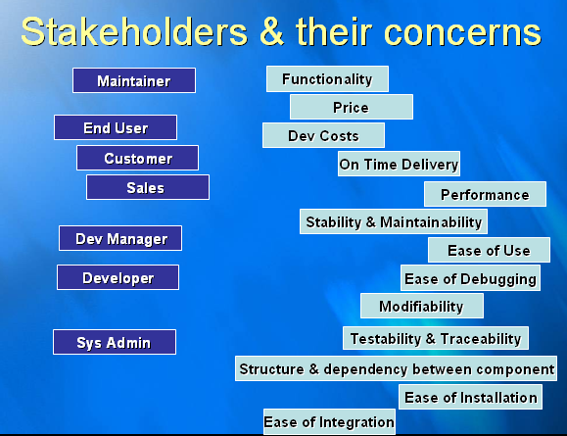

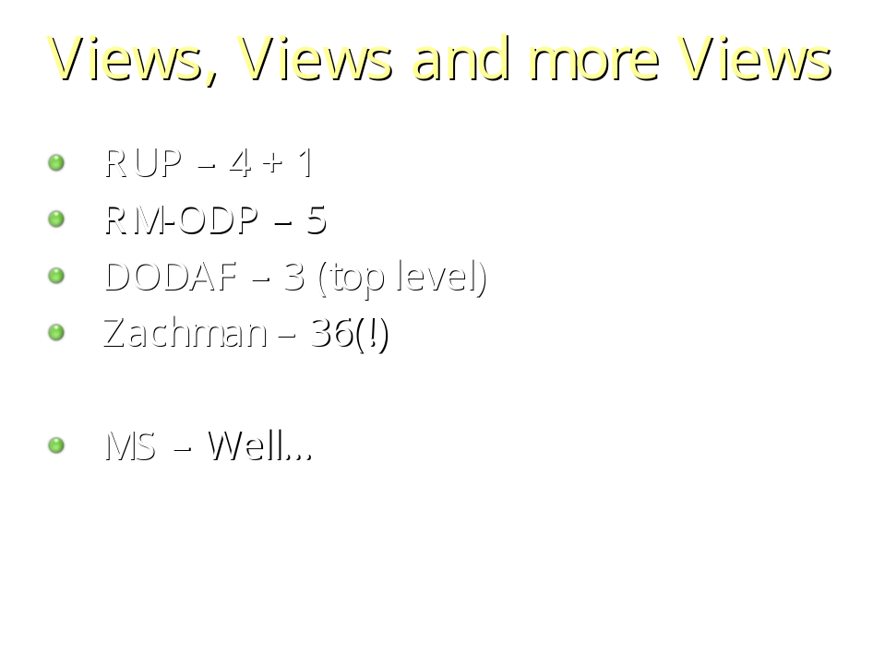

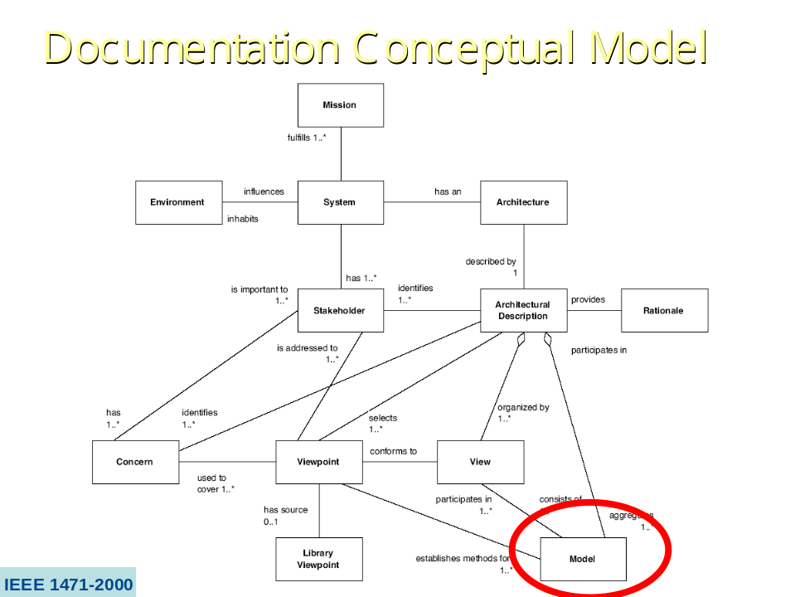

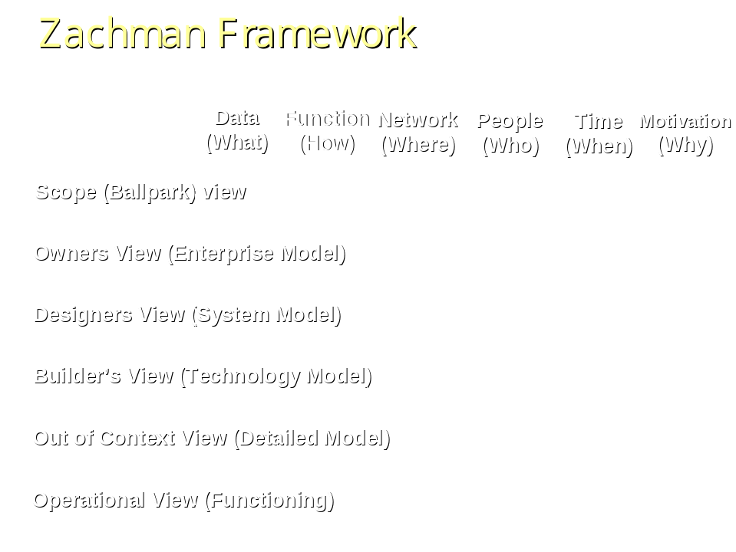

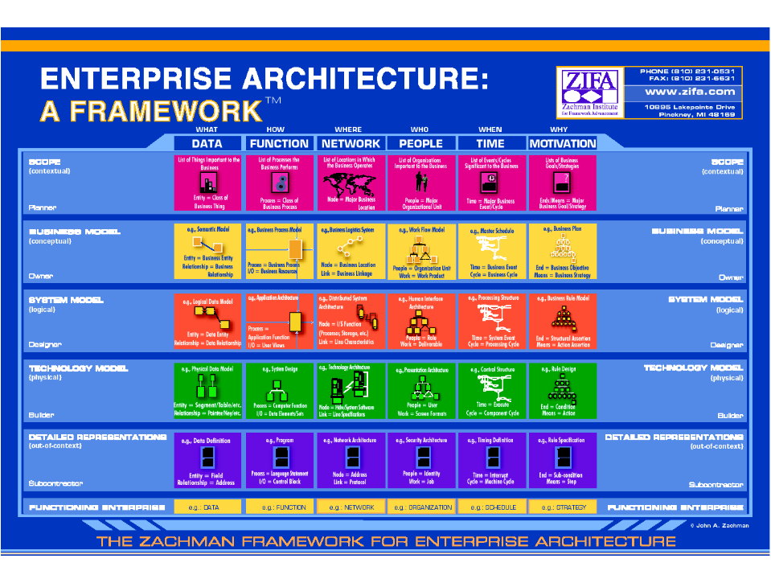

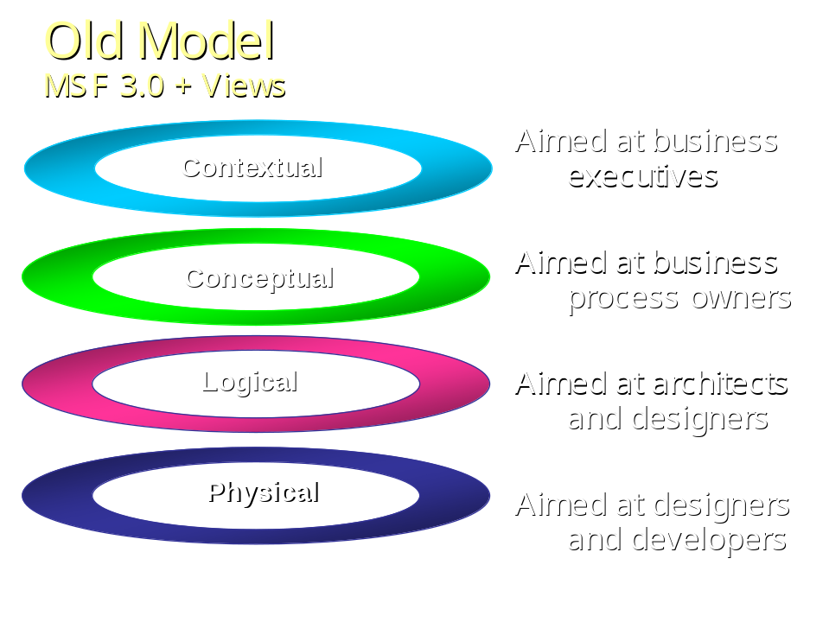

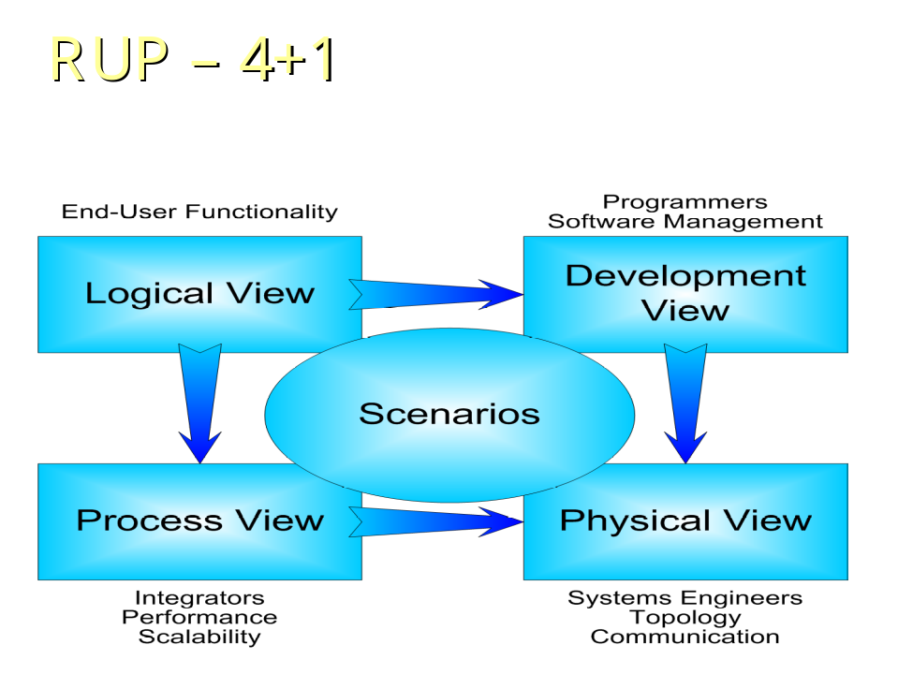

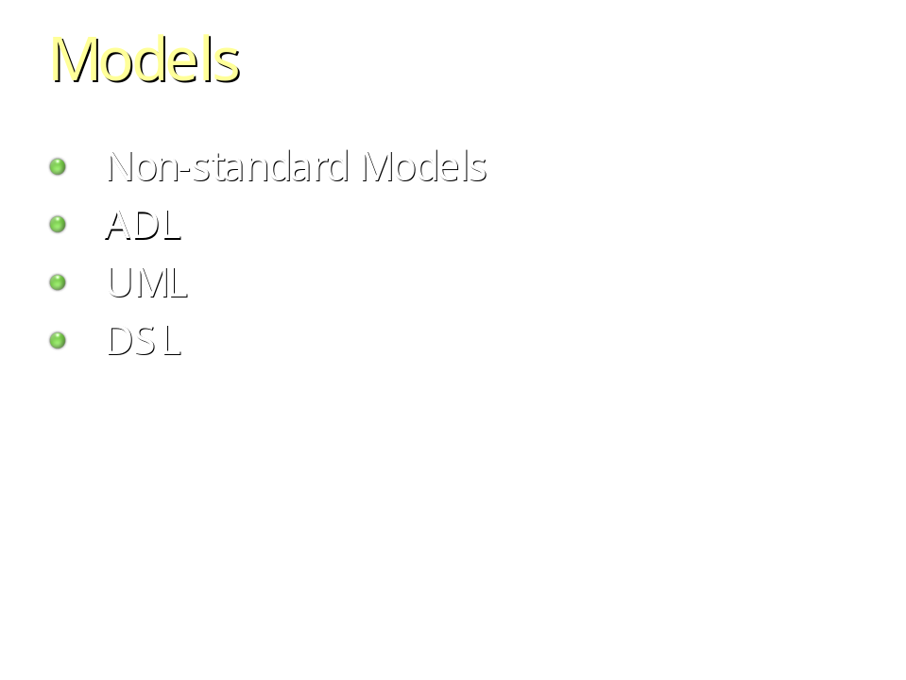

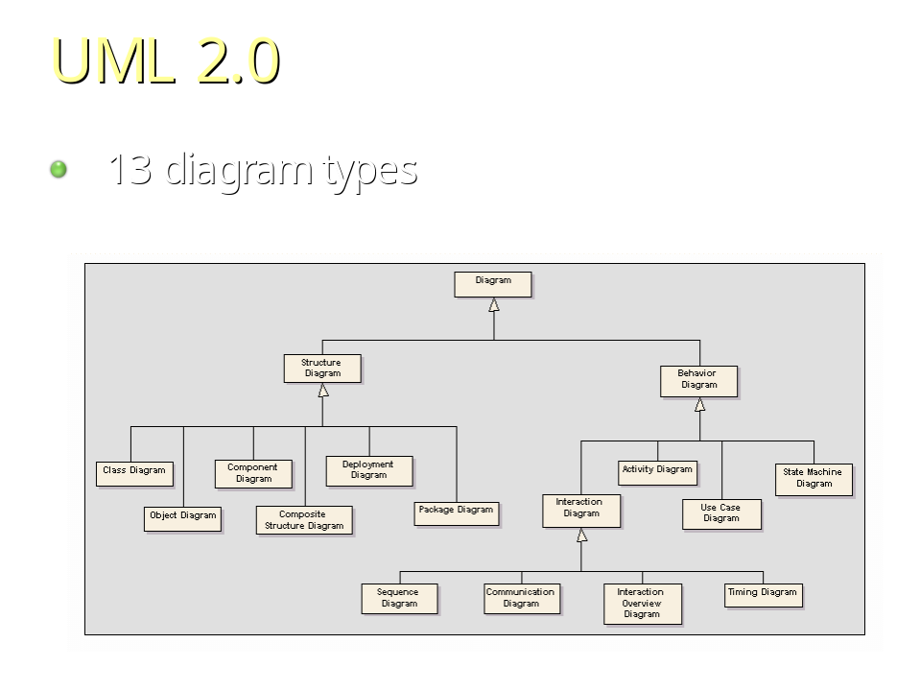

architectural style generally refers to "a set of design rules that identify the kinds of components and connectors that may be used to compose a system or subsystem."
common examples of architectural styles include the Pipe and Filter, Layered, Push Based, and so on

